What is a Shunt?
Shunt systems come in a variety of models but always have two similar components: a catheter, the tubing that transports and diverts the CSF from the ventricles to either the abdominal cavity or right atrium, and a shunt that regulates the pressure or flow of CSF from the ventricles. Valves are manufactured to operate at a specific pressure range. A surgeon chooses a pressure range for the shunt based on experience and the needs of the patient.
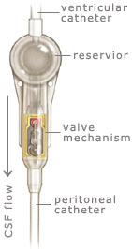Many shunt systems also have a flexible flushing chamber called a reservoir. The reservoir may be housed within the shunt system or added as a component along with the shunt system. The reservoir serves several important functions. It permits the doctor to remove samples of CSF for testing, using a needle and syringe. The doctor also may inject fluid into the shunt system to test for flow; to be sure the system is functioning.
The parts of a shunt system are named according to where they are implanted (placed) in the body. The portion of the tube which is inserted into the ventricles is called the ventricular catheter. The peritoneal catheter is the portion of the tube that drains CSF into the abdominal or peritoneal cavity.
If a drainage tube is placed into the right atrium of the heart it is called the atrial catheter. To get a better understanding of what a shunt system looks like, ask your doctor or nurse to show you samples of the shunts they use. All of the components of a shunt system are made from materials which are well known to be tolerated by the body. For this reason, the entire shunt system is implanted under the skin. There are no external parts.

